Stella Maris College students win the 2024 Malta Junior Science Olympiad.
A team of students from Stella Maris College, Gzira comprising David Anthony Cuschieri, Luke Micallef, and Aiden Xuereb recently won the Malta Junior Science Olympiad 2024.
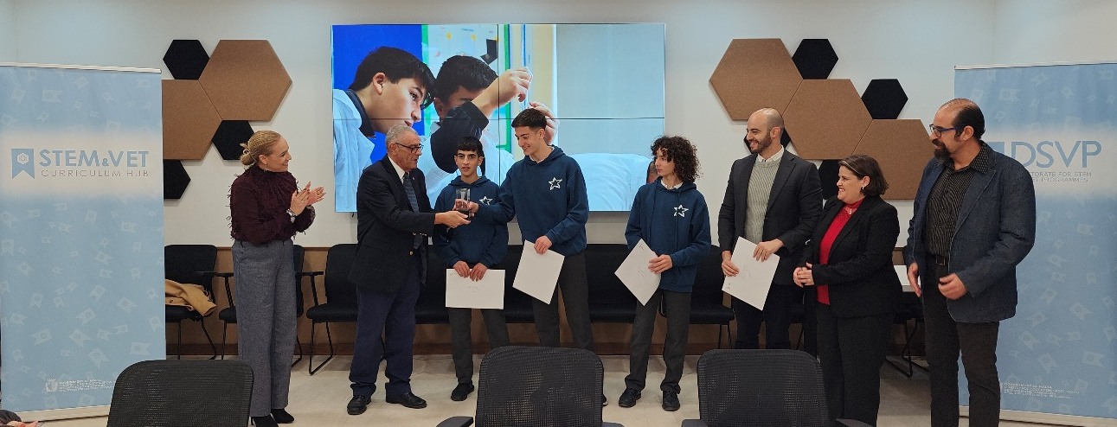
The teams from St. Joseph School Sliema and San Anton School, placed second and third respectively.
This annual event is aimed at students who are talented in STEM (Science, Technology, Engineering, and Mathematics). A total of 60 students participated in this edition. During the competition, teams comprising three students from each participating school collaborated to solve investigative problems in Biology, Chemistry, and Physics. This was made possible thanks to a team of school laboratory technicians.
This year’s winning teams were presented awards sponsored by the Directorate for STEM and VET Programmes. The top team received the Malta Junior Science Olympiad trophy sponsored by the HSBC Malta Foundation.
This was the eleventh edition of the competition, which is organised by the STEM and Curriculum Hub within the Directorate for STEM and VET Programmes.

